For the purpose of theis course we will be using Blender 3.0

It’s okay if you are using an older version as none of the basic function of Blender have changed

But there may be some pretty big user interface differences, especially if you're using Blender 2.7

Or earlier So Teacher don't really recommend using anything earlier than 2.8.

So open the browser and navigate to Blender.org

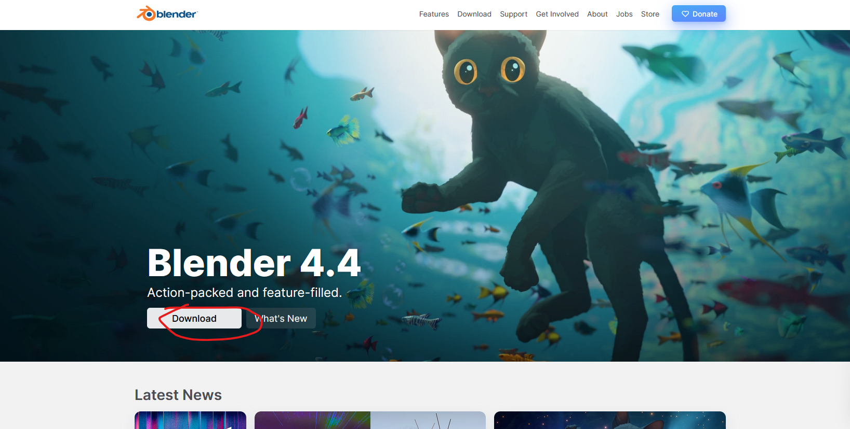

Here you will be presented splash screen just click on the download button as marked above

Teacher is using Window but blender also run on Mac

For the purposes of this course, Teacher is going to be demonstrating on windows.

So if you are using a mac, just be cognizant of the shortcut differences.

But it should be pretty much the same.

Just, you know, using the command key instead of control and all that stuff that you're probably already used to.

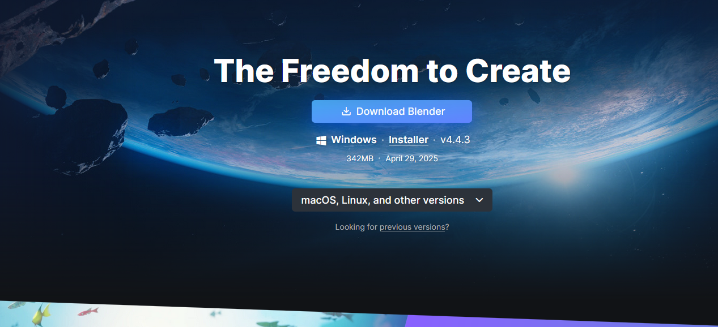

So hit download for whatever platform using



After downloading open the file

It may take a second to compute the space requirements.

If you get a notice right here saying so, no worries, just let it do its thing.

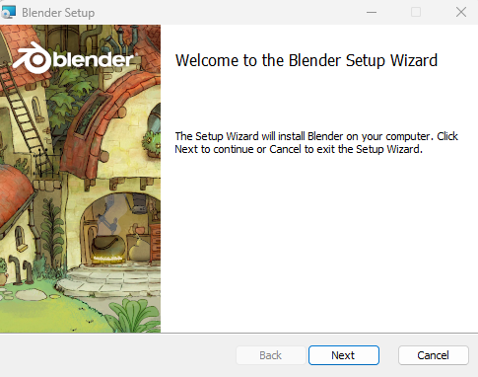

Click on next

Blender is a totally free and open source program, meaning that anyone can contribute to the development of it, but there's no company profiting from its sale or use.

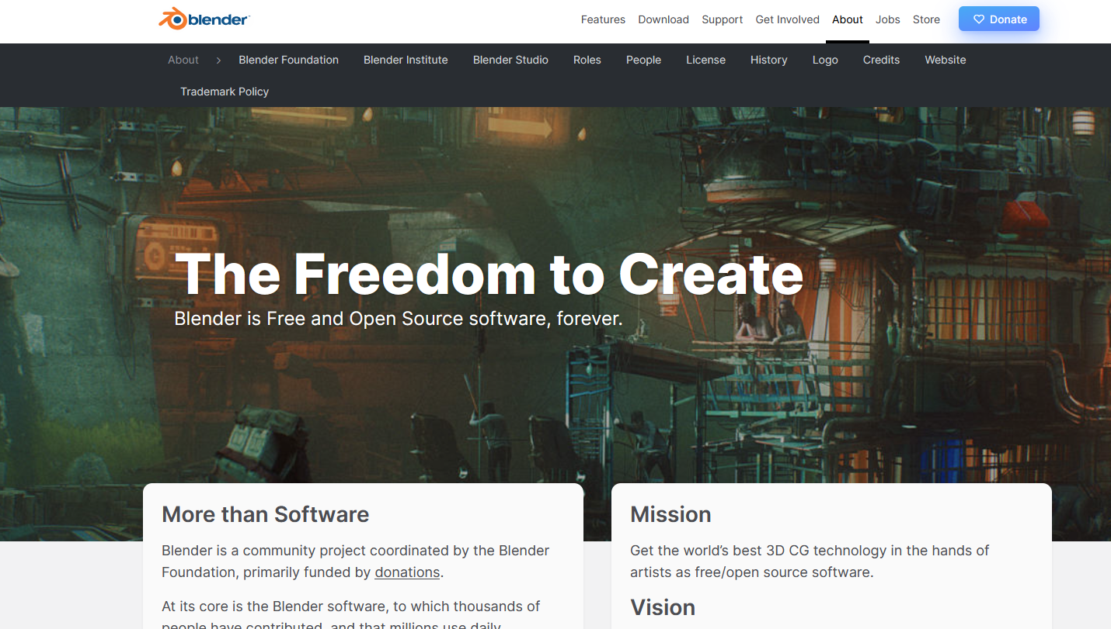

If you want to know more click on about to go to About section as shown above that can tell you more if it works

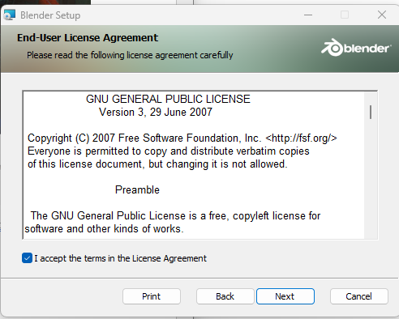

Accept the requirement and then click on next

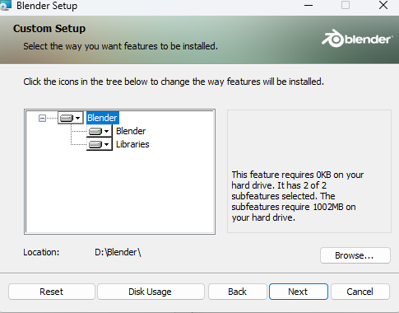

Now you will see the screen that asking you where to write your blender files onto your machine

It is recommend to leave it as it is and then click on next button Unless you have some very specific reason you want it to be in a different location.

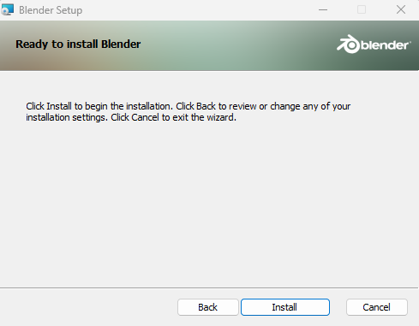

And then in last page click on install button

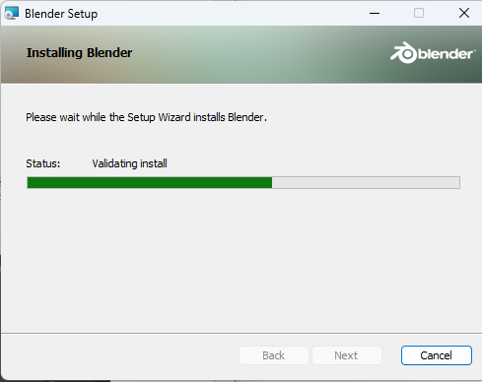

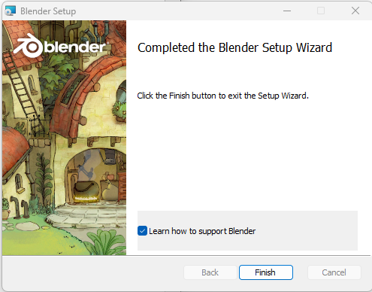

It will be installed and then click on finish button

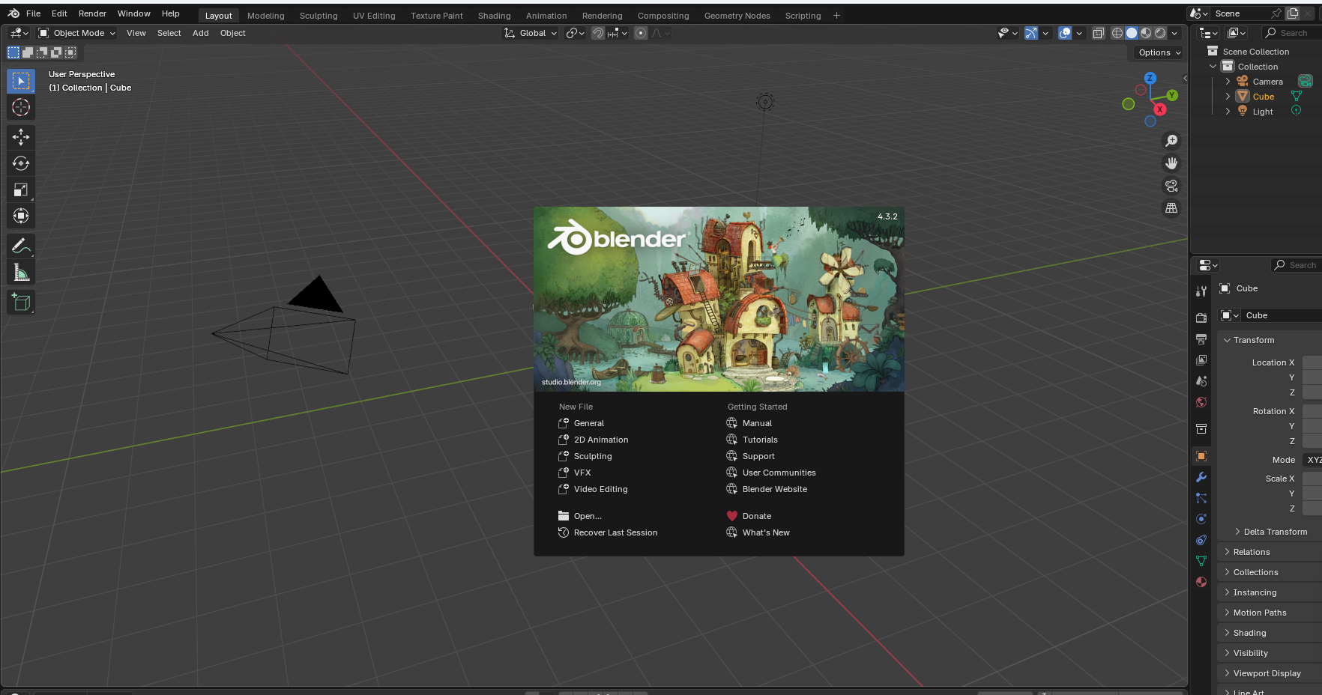

You will be met something along with these lines ( not in first opening )

Teacher just want to make a quick note before we wrap up the installation video on versions.

So like teacher said, we are using Blender 3.03.0.1, actually.

But if for some reason you want or need an older version, those are available to you too when you go to blender.org

Then go to Downloads and then to Previous version

It will show this

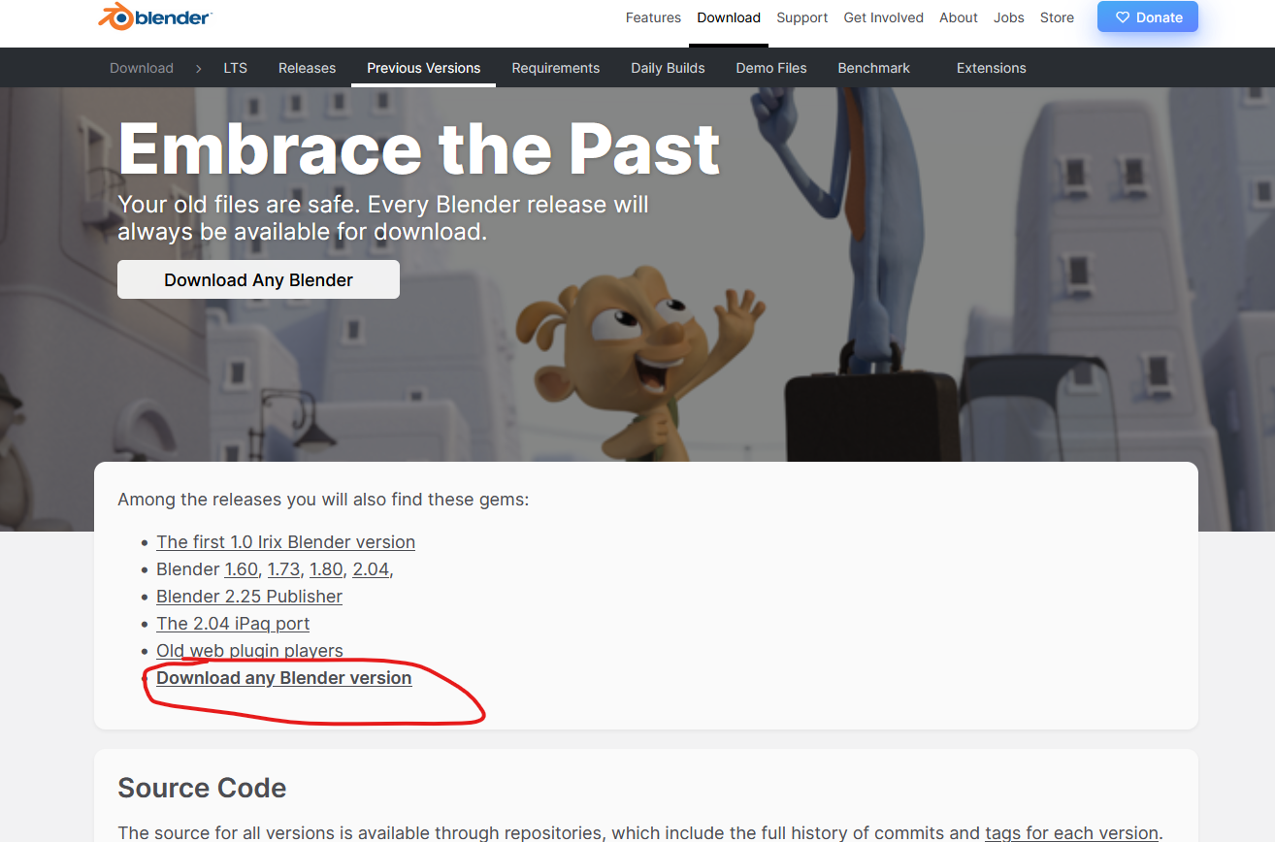

In teachers time

Now you'll get this blurb here about how Blender had a major update between 2.7 and 2.8.

And with that came a lot of UI changes.

So 2.8 is pretty radically different from 2.79, which is why I don't recommend using it as it won't

match really the interface that we're using for this course.

Now in our time I click on Download any Blender version as marked above

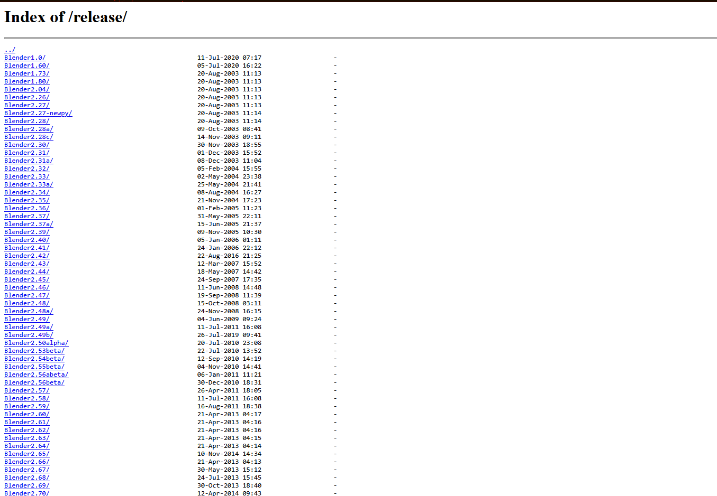

Now a list of different version of blender are given here you can click on anyone to download that version

Now suppose we click on anyone randomly

Suppose version 2.79

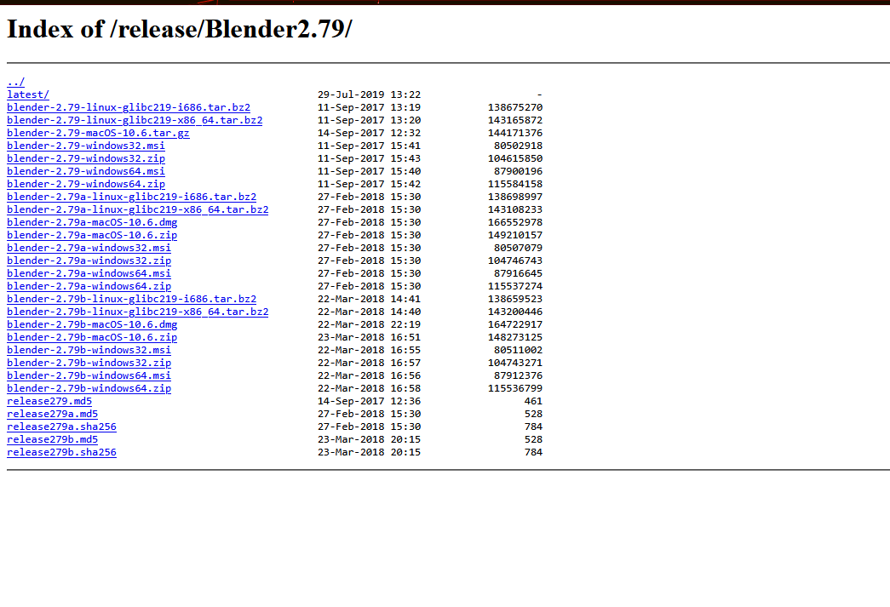

Now we see blender of that version for different platforms for mac, windows etc.

Click on anyone to download it and the downloading process and installing remain the same as we have already discussed now previously we will be using Blender 3.0, which is at the time of this recording, the most recent version of Blender.

So once Blender is installed, it should have made a desktop shortcut.

But either way, open the program. In the next lesson we will learn about actually start using Blender.